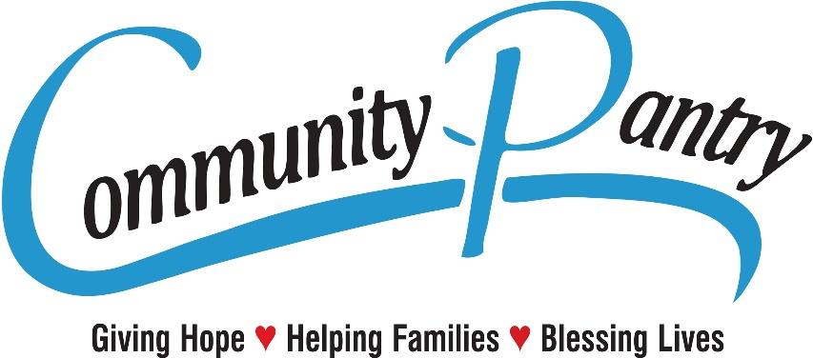

Dear Clients,

We receive almost 800,000lbs of food donations a year. We try to do our best to sort through all the food items, check the dates and throw away the bad and old food. There may be times when we miss an old date here and there. Remember the date on the can or box is not always the expired by date. Regarding the fresh produce and perishable items, we use to throw away the items that may have been questionable, because we did not want to give these food items to our clients. Because we serve very low-income families, we had various clients tell us to give out the food that may be questionable and let the clients decide when they get home if the food is suitable or edible for them. We have changed our policy because of these requests. Please remember you are the end user and you are responsible to inspect the food we provide, and you are to make sure if the food is suitable. We thank you for understanding and allowing us to serve you.

Sincerely the Staff and Volunteers

